PROFILE

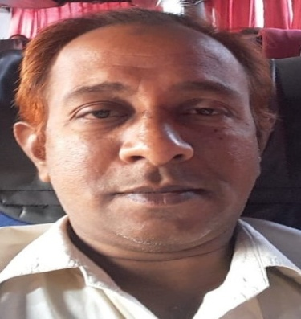
Name :K.BABURAO
Date of Birth :25-08-1973
Father Name :JAGAPATHI RAO

Educational Qualifications :
M.Sc in Chemistry at Andhra University Campus - Visakhapatnam during the year 1993-95
M.Phil in Chemistry at Annamalai University – Chidambaram during the year 2004-05
MBA in Human Resource Management at National Institute of Business Management- Chennai 2006-08

Research Experience :
Worked as Research Associate at Kerala Agricultural University – Trichur from 1996 to 2001
Teaching Experience :
Working as Chemistry Lecturer from 2002 to till today(20 + years)
Previous Examinations passed :
Government Junior College Lecturers(JL) Examination in the year 2007 by APPSC – Hyderabad
Government Degree College Lecturers(DL)Examination in the year 2008 by APPSC – Hyderabad
Government Junior College Lecturers(JL) Examination in the year 2010 by APPSC - Hyderabad

Contact Address :
S/o Sri K. Jagapathi Rao(Late)
Y. Kothuru village
East Godavari District – 533234
Mobile :6303735557
Email id : babu_rk2002@yahoo.co.in

Hobbies : Palmistry & Face reading

